Lecture 3
- Today’s lecture: CO2 , O2 how to get in and out of blood –diffusion.
- Next lecture: blood transport

These are the partial pressure of CO2 andO2 in air.
- In the alveoli ---This is the average number.
In the very first breath, CO2 , and O2 is same as outside
If the air mixes, and happen diffusionthe average PCO2 and PO2 on picture.
- How O2 and CO2 get in and out of the blood?
GAS DIFFUSION
-the gas diffuse through alveolar , capillary membrane.
Diffusion Rate
The transfer of gases across the alveolar-capillary membrane occurs by passive diffusion. This diffusion is very efficient in the lungs because of the huge surface area of the membrane and its extreme thinness.
- Gas exchange by passive diffusion. This diffusion is proportion to surface area. (The surface area of alveoli is like the tennis court—enormous) and to PX(partial) pressure gradient (More difference , diffuse more readily).
- It is inverse proportion to the thickness of alveoli, capillary membrane. (The membrane here is very thin)
- Diffusion is governed by Fick's Law: Diffusion rate is proportion surface area (50-100 m²)
- Proportion: partial pressure gradient
- proportion: 1/thickness (~0.2 mm)

- 1st ) The oxygen have to diffuse through a small layer of fluid. ( The layer of fluid and surfactant inside the alveoli.)

- 2nd) O2 have to go through alveolar epithelium,

- 3rd) through the interstitial space

- 4th) The capillary basement membrane than endothelium

- 5th) In to the plasma

- 6th) finally to RBC

- CO2 and O2 in opposite direction, and all by passive diffusion.
-Notice we not only have membrane but also fluid (interstitial fluid, surfactant, plasma)

To diffuse through a liquid, a gas must be soluble in the liquid. The amount of gas dissolved is proportional to its partial pressure (Henry’s law). (The higher pressure gradient, the greater rate will be. )
- Gas need to be soluble in the fluid.
- Because CO2 is considerably more soluble than O2 in water, it diffuses ~20 times more rapidly than O2.
- Solubility: CO2 (20 times faster) > O2. (O2 is not soluble in water.)
- They don’t have the same solubility and partial pressure.
- PO2 have a (105-40 = 60) mmHg partial gradient. PO2 has (46-40) mmHg partial gradient. (PC02 difference is ten times smaller than 02)
- O2 have large pressure difference but low solubility.
- Co2 has a low pressure difference but high solubility.
- They end up diffuse at the same time.
- Why Po2 end up 100mmHg instead of 105 mmHg, and Pco2 ARE BOTH 40 mmHg because: Co2 is really soluble it changes the pressure quickly. O2 is so not soluble, even though you have a greater input to blood , ther pressure won’t be 105 .(detail, unnecessary.)
•However, the difference in PCO2 between the 2 sides of the alveolar- capillary membrane is 10 times smaller than that for PO2. Therefore, the time required for equilibrium between alveolar air and capillary blood is ~ the same for the two gases.
Transit Time

- This slide is very important.
- As it comes in from pulmonary artery (on the left) go to capillary(middle). End up in Pulmonary vein (right)
- The time start: 0
End time 0.75 sec (It take about 0.75 sec to pass through for one RBC)
-Saturation of O2:
As it starts going, the partial pressure goes up . (40 mmHg 100mmHg) This occur about 0.3 sec. The RBC have plenty of time to happen saturation.
-Decrease saturation of CO2:
It goes from 46 to 40 mmHg in 0.3 sec.
- The solubility and pressure difference make its end up to the same time for saturation of O2 and CO2
- What happen if the condition changed?
- Instead of normal person, a subject with pulmonary edema
- pulmonary edema: thickening of the alveolar capillary membrane, it means fluid accumulating in interstitial space. This happen when left heart failure. => blood not pumping. => Blood accumulate in the lungs and diffuse to alveoli interstitial space. You end up have fluid accumulation in the space. This is the thickening of alveolar membrane which is polar edema.
- The diffusion rate is reversely proportion to alveolar membrane, so when in edema thicken. This decrease the diffusion.
- This patient will follow the dotted line. The diffusion slow down => saturation and desaturation slow down.
- In picture => Patient still able to reach the saturation, will RBC pass through capillary.
- If the patient, try to exercise.
- Blood flow increase (time pass through shorter) , increase cardiac output. Try to make more blood to muscle. RBC go through alveolar capillary faster (0.25 sec.) This is fine for a normal subject, but this patient is not able to reach the saturation state, and desaturation CO2.
- This is not due to the inappropriate ventilation.
- If in the case of hypoventilation, PO2 decrease, you will not able to saturate to 100mmHG. Same thing for the rate.

IV Pulmonary blood flow
Compare the blood flow of pulmonary system to systemic circulation.
- Pulmonary Circulation and Blood Pressure
- The left heart pump harder than right to supply the system. Because the left heart pump blood to the whole systemic circulation. This will make sure, the blood able to reach finger.
- The right heart only pump to the lungs, the lungs however are at the same level as the heart. Don’t need to generate as much force.
The pulmonary circulation differs in many ways from the systemic one:
- The right ventricle develops a pressure of ~25 mmHg during its systole(during contraction) (compared to 120mmHg in the left ventricle);
- Systemic circulation has a higher pressure than pulmonary circulation.
- You need a high pressure in systemic system (to pump to the fingrs) but low pressure in the lung(you don’t want to create edema)
- Blood pressure in the pulmonary circulation is lower than in the systemic circulation;
- The pulmonary blood vessel are thinner and contain less smooth muscle than comparable vessels in the systemic circulation.
- This allow the lower pressure system
Summary:

- The left ventricle (left heart) will pump 120 mmHg generate 120 mmHg in systemic. When it relaxes the systemic artery goes down to 80mmHg. In average, the arterial artery is 100mmHg.
- The right ventricle (left heart) will pump 25 mmHg generate 25 mmHg in pulmonary circulation. When it relaxes the systemic artery goes down to 8mmHg. In average, the arterial artery is 15mmHg.
- 15mmHg compares 100mmHg. Pulmonary has a lower pressure condition.
- When it goes through the whole system, the pressure drop 100 mmHg when it goes through the whole system to the right heart. (120 mmHg drop to 2 mmHg)
- When it goes through the whole system, the pressure drop 10 mmHg when it goes through the whole system to the right heart. (15 mmHg drop to 5 mmHg)
- There is a 10 folds difference in pressure drop.
- Now think about this:
- You don’t have the same pressure but the whole blood flow is same.
- The blood come from systemic circulation from right heart will all be sent to pulmonary circulation. (the whole blood will flow from one system to the other)

B. Vascular Resistance

- Flow = pressure / resistance (memeorize!!)
- Imagine a pipet with a fluid to flow through, we can push on one edge. If the pipet is small, you need to push harder. (The greater resistant against flow) => flow is made by pressure in resistant.
- If you want the same flow, but decrease the pulmonary circulation. => need to Decrease the resistant.
- High pressure on systemic site but same flow as pulmonary circulation. Low pressure in pulmonary circulation. The resistant of pulmonary and systemic is not the same. The resistant of the pulmonary space is lower to have the same flow.
- •Total pressure drop from pulmonary artery to left atrium of about 10 mm Hg.
- The pulmonary resistance is ~1/10 that of the systemic circulation.
- •The low vascular resistance in the pulmonary circulation relies on the thin walls of the vascular system.
- •The low vascular resistance and high compliance of the pulmonary circulation allows the lung to accept the whole cardiac output at all times.

The pulmonary circulation has the capacity to accommodate two- to three-fold increases in cardiac output with little change in pulmonary arterial pressure.
- - To increase blood vessel, decrease the resistant

- Accommodation of Pulmonary Blood Vessels
The pulmonary circulation has the capacity to accommodate two- to three-fold increases in cardiac output with little change in pulmonary arterial pressure.
For example: You are exercising and need to increase the blood flow, but you don’t want to increase the pressure. ==>Need to decrease the resistant.

- you open up MORE capillaries to increase the flow. This accommodate more blood flow.
- Some of them can distend more. The floppy blood vessel, it can expand and accommodate more blood flow.
- Without increase the pressure to decrease the resistant (Open up more blood vessel, and Distension.)

- Accommodation of Pulmonary Blood Vessels (Cont’ed
•Drugs (serotonin, histamine, norepinephrine) which cause the contraction of smooth muscle increase pulmonary vascular resistance in the larger pulmonary arteries.

•Drugs (acetylcholine, isoproteranol) which can relax smooth
muscle may decrease pulmonary vascular resistance.

•There is a reflex vasoconstriction in regions of the lungs that are poorly oxygenated.
•Nitric oxide produced by endothelial cells relaxes vascular smooth muscle leading to vasodilation.
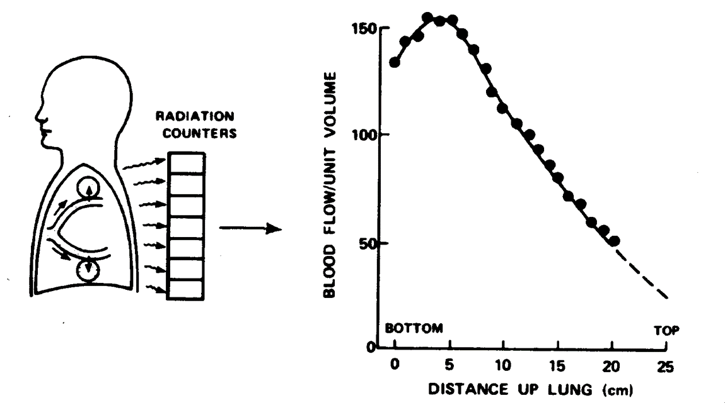
- Effects of Gravity on pulmonary blood flow distribution.
- look at the general trend:
- More blood flow go to the bottom than the upper due to the attraction of gravity. (Prefer to go to the bottom due to gravity)
- Pulmonary blood flow is affected by gravity.
- Test performed by injecting radioactive Xenon in a peripheral vein
- Inject Xenon
  - As the Xenon go through pulmonary capillary, (it is unsolvable.) Go into the blood into alveoli. => detect. => More radiation at the bottom than the top of the lung.
  - Patient lying => more blood flow in the back part. Patient in space (no gravity ) => even blood flow distribution
  - In space: much more a straight line, more even.

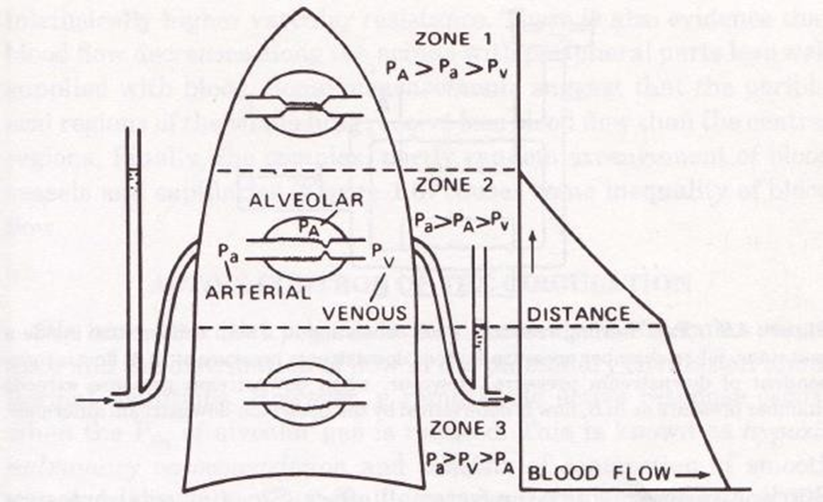
Divide the lungs into 3 sections. You not only have the gravity, also have another factors (pressure).
A colon of the blood:
- The blood go to the top don’t have that much pressure due to the against of gravity.
- Blood comes down have a high pressure.
The lower we are, the greater the flow.
- The higher you go, the less flow.
The blood vessel around the alveoli.
- If the alveolar pressure is greater than the blood vessel
- It will squeeze them! (The top zone1 ) . The arterial blood the pressure is less. However, The alveolar pressure is the same everywhere!
- In zone 1, alveolar vessel can be squeeze by alveoli! Might not able to get any blood flow.
- There is no blood flow, if subject is pathology (with hemorrhage, low blood vessel.)
- In zone 2, Since the arterial pressure isn’t great, sometimes the venous pressure is not low enough to have blood flow.

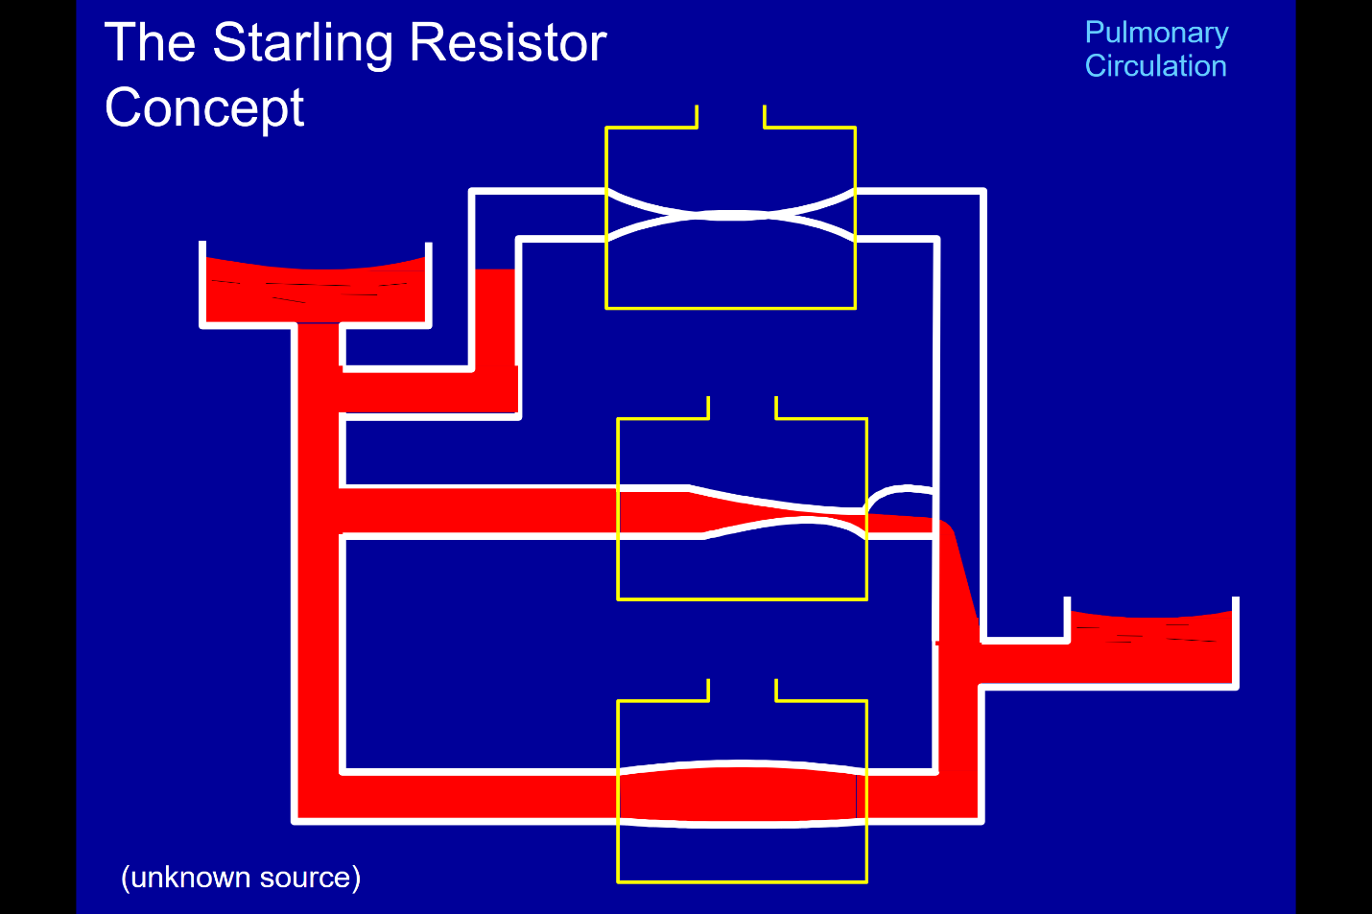
This is the animation of 3 zones.
The left top is the heart pump.
- The artery go to bottom , with much pressure with them( and the gravity) lead to blood flow.
- At zone 1, the pressure is not high enough to get into artery. P alveolar > P capillary. => Capillary get squeezed, closed off => no blood flow.
- At zone 2 (middle). P Arterial > P alveolar. But! The venous pressure is not that low. Some blood flow, with squeezing happened. The squeeze, and blood accumulate when it is high enough. It can be released.( This is the middle situation between zone1 and zone3).
Key : Gravity affect the blood flow, but it is not the same everywhere. We need to account arterial, venous, alveolar pressure. (Its complex)

- Effects of Gravity on Ventilation
- we want the best ventilation at the best blood flow for gass exchange.
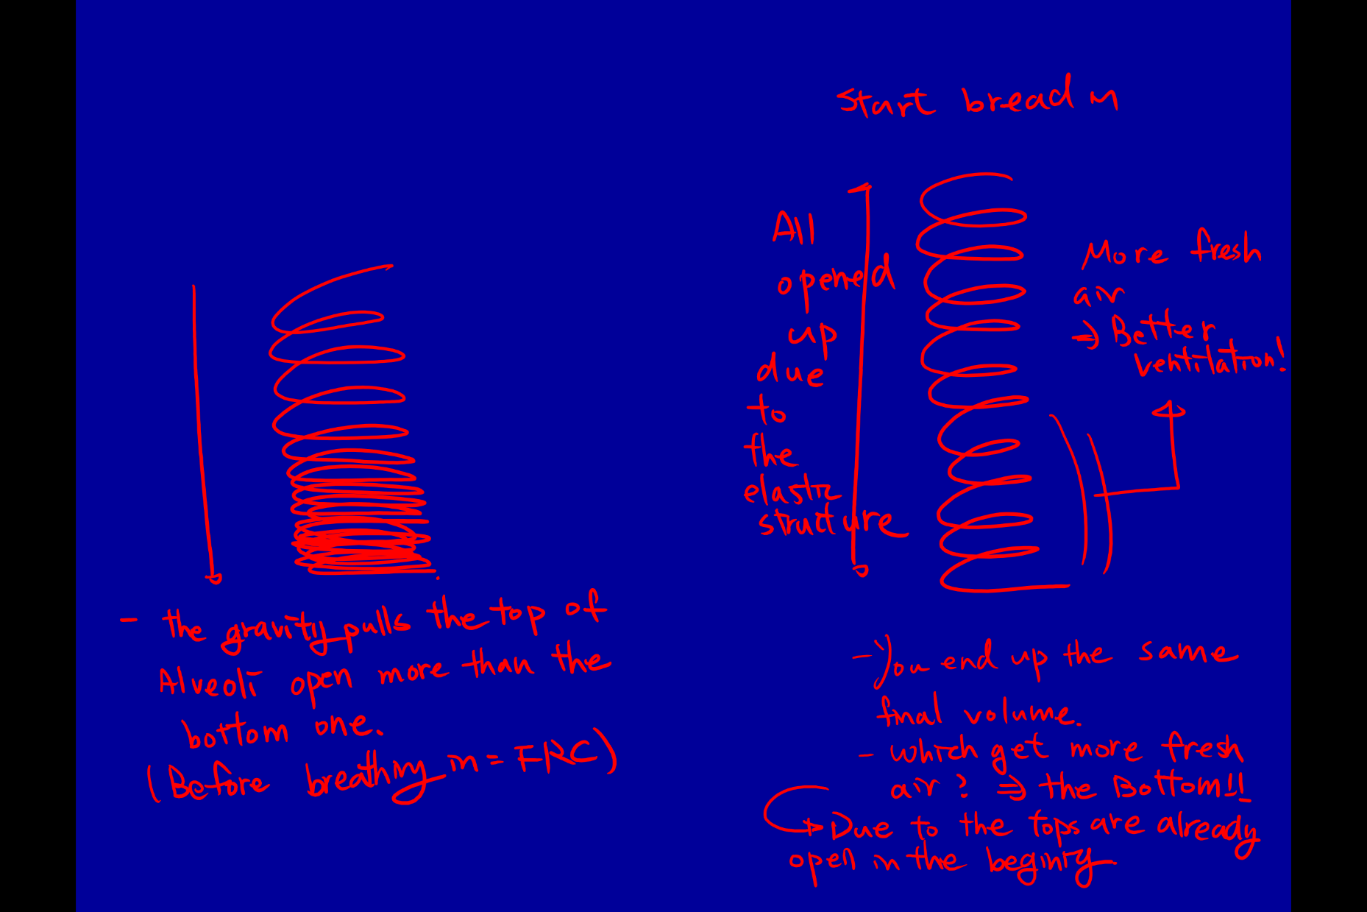
- Do we have the best ventilation at the bottom of the lungs
•Gravity also affects the distribution of ventilation.

This is a subject measured ventilation.
- Breathe in: Radioactive Xe
- More Xe at the bottom of the lung than the top
- We have the best ventilation and blood flow at the botton.
- We should have perfect gas exchange! But no! We are not that perfect.

•In an upright lung at rest, in normal gravity, the alveoli at the top of the lungs are more opened than the bottom ones (think of a “Slinky” held in normal gravity)
•The distribution of ventilation can be measured in a similar way as that of perfusion but with inhaled radioactive Xenon instead of infused in the blood.

We should have perfect gas exchange! But no! We are not that perfect.
- Distribution of ventilation perfusion ratio in the lungs in normal gravity.

This show the blood flow, ventilation relation ship from bottom to the top
- The blood is more affected (higher) than the ventilation at the bottom .
- More blood flow than ventilation at the bottom.
- We have more ventilation at the top than the bottom.
- Q= blood flow . Va = ventilation .
- The ratio give you a complex curve. this is us in normal gravity.

